

**FPT ACADEMY INTERNATIONAL**

**FPT – APTECH COMPUTER EDUCATION**

**DOMAIN**

*Ryana Calendars*

Development Guide

|  |  |  |  |
| --- | --- | --- | --- |
| **Center Name** | | FPT – Aptech – HCM2  Address: 590 Cach Mang Thang Tam, District 3, Ho Chi Minh City | |
| **Instructor** | | Mr. Ngo Phuoc Nguyen | |
| **Class** | | T1.2009.A0 | |
| **Group** | | 3 | |
| **Group members** | | **Name** | **Student ID** |
| Nguyen Duc Dung | Student1279565 |
| Phan Duy Nghia | Student1277252 |
| Nguyen Duc Nam | Student1279119 |
| Nguyen Van Thuc | Student1279115 |
| **Duration** | **Start date** | 30 Nov 2020 | |
| **End date** | 30 Dec 2020 | |

**This is to certify that**

**Mr.:**

Nguyen Duc Dung

Nguyen Duc Nam

Phan Duy Nghia

Nguyen Van Thuc

**has successfully designed & developed**

eProject: Ryana Calendars

**Submitted by:**

Nguyen Duc Dung

**Date of issue:** 30 Nov 2020

**Authorized Signature:**

TABLE OF CONTENTS

INTRODUCTION 3

OBJECTIVES of the project 4

Problem Statement 5

HARDWARE/SOFTWARE REQUIREMENT 6

Scope of the work (in brief) 7

Architecture and design of the system 8

Diagram of the website 9

SITE MAP 11

Mock of the website 12

1. Home 12

2. Sign In 14

3. Diary 15

4. Calendar 16

5. About Us 17

6. Contact 17

WEBSITE DESCRIPTION 19

1. Home 19

2. Sign In 23

3. Diary 24

4. Calendar 26

5. About Us 28

6. Contact 29

JAVASCRIPT DESCRIPTION 30

1. Slide Sign In form 30

**Introduction**

The thirst for learning, upgrading technical skills and applying the concepts in real life environment at a fast pace is what the industry demands from IT professionals today. However busy work schedules, far-flung locations, unavailability of convenient time-slots pose as major barriers when it comes to applying the concepts into realism.  And hence the need to look out for alternative means of implementation in the form of laddered approach.

The above truly pose as constraints especially for our students too! With their busy schedules, it is indeed difficult for our students to keep up with the genuine and constant need for integrated application which can be seen live especially so in the field of IT education where technology can change on the spur of a moment. *Well, technology does come to our rescue at such times!!*

Keeping the above in mind and in tune with our constant endeavour to use Technology in our training model, we at Aptech have thought of revolutionizing the way our students learn and implement the concepts using tools themselves by providing a *live and synchronous eProject   learning environment!*

**So what is this eProject?**

eProject is a step-by-step learning environment that closely simulates the classroom and Lab based learning environment into actual implementation. It is a project implementation at your fingertips!! An electronic, live juncture on the machine that allows you to

* Practice step by step i.e. laddered approach.
* Build a larger more robust application.
* Usage of certain utilities in applications designed by user.
* Single program to unified code leading to a complete application.
* Learn implementation of concepts in a phased manner.
* Enhance skills and add value.
* Work on real life projects.
* Give a real life scenario and help to create applications more complicated and useful.
* Mentoring through email support.

The students at the centre are expected to complete this eProject and send complete project along with the documentation to eprojects@aptech.ac.in

Looking forward to a positive response from your end!!

**Objectives of the project**

The Objective of this program is to give a sample project to work on real life projects. These applications help you build a larger more robust application.

The objective is not to teach you JavaScript/Dreamweaver but to provide you with a real life scenario and help you create basic applications using the tools.

You can revise the chapters before you start with the project.

This project is meant for students who have completed the module of ***HTML5***. These programs should be done in the Lab sessions with assistance of the faculty if required.

It is very essential that a student has a clear understanding of the subject. Students should go through the project and solve the assignments as per requirements given.

Kindly get back to [eprojects@aptech.ac.in](mailto:eprojects@aptech.ac.in) in case of any doubts regarding the application or its objectives.

**Problem Statement**

Ryana Calendars is selling various Calendars and Diary products. The company advertises by distributing the pamphlets, advertising on television and so on. Due to rapid development in internet field, the company decides to launch a website where people will get all the information about the various products available with them easily.

The website is to be developed for the Windows Platform using HTML5, JavaScript and Geolocation. The site should work well in all leading browsers including Chrome, IE, Firefox etc.

**Requirement Specification:**

The Web site is to be created based on the following requirements.

1. The Home Page should be created making use of Sections with a suitable logo
2. The site should display a menu which will contain the options for brief introduction about the various products available, location of the shop and any other information if required.
3. The information should be categorized according to different type of products like if a User wants to see only ‘Journal’ then he click on a Link/button/menu etc and he will see different type of Journal. Similarly for ‘Calendars’, ‘Diaries’ and other products
4. When a user selects any product type, a list of products for that product type will be displayed.
5. A brief summary of features of individual products should be displayed on the Web Page along with the product but detailed Features should be stored in Individual Word documents which can be downloaded or viewed by the User who wishes to see the same.
6. Price List should be available for download.
7. There should be a “Contact Us” page which will have the Address of the Company which should be displayed using GeoLocation API (eg. GoogleMaps) and the email address which when clicked will invoke the local mail client from where they can send an email.

**Hardware/ Software Requirements**

**Hardware**

* A minimum computer system that will help you access all the tools in the courses is a Pentium 166 or better
* 64 Megabytes of RAM or better

**Software**

* Notepad/HTML editor
* Dreamweaver
* IE 5.0/ Netscape 6.0

**Scope of the work (in brief)**

After a long and detailed discussion, our group has decided to create a website contain the

following webpages:

1. ***Homepage (RYANA CALENDARS on the left):*** Display a short paragraph of information

about the diaries and the calendars and the cost of them.

2. ***Imaging CALENDARS:*** Display a catalogue of the Ryana Calendars in the world according to

Show All Calendars.

3. ***Imaging DIARIES:*** Display a catalogue of the Ryana Calendars in the world according to

Show All Diaries.

4. ***Sign In:*** Sign in your account to buy the Diaries and the Calendars

5. ***About Us:*** Contain social proof, testimonials, and some personal information that visitors can relate to, such as education, family, etc.

6. ***Contact:*** Allow customers to request any information they want to Ryana Calendars

Website.

# Architecture and design of the system

**WEB SERVER (or Local Sever)**

Webpage request

**WEB BROWSER**

Requested Page

**RENDERING ENGINE**

INTERPRETATION

INTERPRETATION

# 

# 

# Diagram of the website

**Homepage**

**Diary**

**Calendars**

**Sign In**

**About Us**

**Contact**

**TASK SHEET REVIEW 1**

|  |  |  |  |  |  |  |  |
| --- | --- | --- | --- | --- | --- | --- | --- |
| **Project Ref. No.:**  **eP/Advertisement** **Portal Management** **System/01** | | **Project Title:** | **Activity Plan** **Prepared** **By:** | **Date of Preparation of Activity Plan:** | | | |
| **Sr.No.** | **Task** | **Actual Start** **Date** | **Actual** **Days** | **Team** **Mate** **Names** | **Status** |
| 1 | Problem Statement | Ryana  Calendars | DUNG | 30/11/2020 | 1 | DUNG | Completed |
| 2 | Analysis of Ryana Calendars requirements about the website | 30/11/2020 | 1 | DUNG | Completed |
| 3 | The scope of the work (in brief) | 30/11/2020 | 1 | DUNG | Completed |
| 4 | Architecture and design of the system | 30/11/2020 | 1 | DUNG | Completed |
| 5 | Diagram of the website | 30/11/2020 | 1 | DUNG | Completed |
| 6 | Task Sheet | 30/11/2020 | 1 | DUNG | Completed |

|  |  |
| --- | --- |
| **Date:** | |
| Signature of Instructor:  **Mr. Ngo Phuoc Nguyen** | Signature of Team Leader:  **Nguyen Duc Dung** |

# SITE MAP

**Home**

**Find your product Calendar and Diary**

**Show All**

**Name**

**Calendars**

**Size**

**Description**

**Cost**

**Contact**

**Contact Form**

**Our Location**

**Diaries**

**Description**

**Cost**

**Size**

**Name**

**Website**

**Sign In to buy**

**Sign In**

**Information Developer Members**

**About Us**

# Mock of the website

* 1. Home

|  |  |
| --- | --- |
| LOGO | NAVIGATION BAR |
| BANNER | |
| |  | | --- | | IMAGE |  |  | | --- | | TEXT |  |  | | --- | | IMAGE |  |  | | --- | | TEXT |  |  |  |  | | --- | --- | --- | | IMAGE | IMAGE | IMAGE |  |  |  |  | | --- | --- | --- | | NAME | NAME | NAME |  |  | | --- | | TEXT |  |  |  |  |  | | --- | --- | --- | --- | | IMAGE | IMAGE | IMAGE | IMAGE |  |  |  |  |  | | --- | --- | --- | --- | | NAME | NAME | NAME | NAME |  |  | | --- | | TEXT |  |  | | --- | | IMAGE |  |  | | --- | | TEXT |  |  |  |  |  |  |  | | --- | --- | --- | --- | --- | --- | | IMAGE | IMAGE | IMAGE | IMAGE | IMAGE | IMAGE |  |  |  |  |  |  |  | | --- | --- | --- | --- | --- | --- | | NAME | NAME | NAME | NAME | NAME | NAME | | |
| |  | | --- | | TEXT |  |  |  |  | | --- | --- | --- | | IMAGE |  | TEXT |  |  | | --- | | TEXT |  |  |  |  | | --- | --- | --- | | TEXT |  | IMAGE |  |  | | --- | | TEXT |  |  |  |  | | --- | --- | --- | | IMAGE |  | TEXT | | |
| FOOTER | |

* 1. Log In

|  |  |
| --- | --- |
| LOGO | NAVIGATION BAR |
| |  | | --- | | SIGN IN FORM |  |  | | --- | | IMAGE |      |  | | --- | | IMAGE | | |
| FOOTER | |

* 1. Diaries

|  |  |
| --- | --- |
| LOGO | NAVIGATION BAR |
| IMAGE | |
| |  |  |  |  |  |  |  | | --- | --- | --- | --- | --- | --- | --- | | IMAGE |  | IMAGE |  | IMAGE |  | IMAGE | | NAME |  | NAME |  | NAME |  | NAME | |  |  |  |  | | IMAGE | IMAGE | IMAGE | IMAGE | | NAME |  | NAME |  | NAME |  | NAME | |  |  | | | | | | IMAGE | IMAGE |  | IMAGE |  | IMAGE | | NAME |  | NAME | NAME | NAME | |  | | | | | | | | IMAGE |  | IMAGE |  | IMAGE |  | IMAGE | | NAME | NAME | NAME | NAME | |  | | | | | | | | IMAGE |  | IMAGE |  | IMAGE |  | IMAGE | | NAME | NAME | NAME | NAME |  |  | | --- | | CATEGORIES |      |  | | --- | | PRICES | | |
| HOW TO CHOOSE | |
| FOOTER | |

* 1. Calendars

|  |  |
| --- | --- |
| LOGO | NAVIGATION BAR |
| IMAGE | |
| |  |  |  |  |  |  |  | | --- | --- | --- | --- | --- | --- | --- | | IMAGE |  | IMAGE |  | IMAGE |  | IMAGE | | NAME |  | NAME |  | NAME |  | NAME | |  |  |  |  | | IMAGE | IMAGE | IMAGE | IMAGE | | NAME |  | NAME |  | NAME |  | NAME | |  |  | | | | | | IMAGE | IMAGE |  | IMAGE |  | IMAGE | | NAME |  | NAME | NAME | NAME | |  | | | | | | | | IMAGE |  | IMAGE |  | IMAGE |  | IMAGE | | NAME | NAME | NAME | NAME | |  | | | | | | | | IMAGE |  | IMAGE |  | IMAGE |  | IMAGE | | NAME | NAME | NAME | NAME |  |  | | --- | | CATEGORIES |      |  | | --- | | PRICES | | |
| HOW TO CHOOSE | |
| FOOTER | |

* 1. About Us

|  |  |
| --- | --- |
| LOGO | NAVIGATION BAR |
| OUR TEAM   |  |  |  |  |  |  |  | | --- | --- | --- | --- | --- | --- | --- | | IMAGE |  | IMAGE |  | IMAGE |  | IMAGE | | NAME | NAME | NAME | NAME | | POSITION | POSITION | POSITION | POSITION | | CONTACT | CONTACT | CONTACT | CONTACT | | |
| FOOTER | |

* 1. Contact

|  |  |
| --- | --- |
| LOGO | NAVIGATION BAR |
| |  |  | | --- | --- | | GOOGLEMAP | CONTACT FORM | | |
| FOOTER | |

**TASK SHEET REVIEW 2**

|  |  |  |  |  |  |  |  |
| --- | --- | --- | --- | --- | --- | --- | --- |
| **Project Ref. No.:**  **eP/Advertisement** **Portal Management** **System/01** | | **Project Title:** | **Activity Plan** **Prepared** **By:** | **Date of Preparation of Activity Plan:** | | | |
| **Sr.No.** | **Task** | **Actual Start** **Date** | **Actual** **Days** | **Team** **Mate** **Names** | **Status** |
| 1 | Site map | Ryana  Calendars | DUNG | 11/12/2020 | 1 | DUNG | Completed |
| 2 | Mock of the website | 11/12/2020 | 1 | DUNG | Completed |
| 3 | Task sheet | 11/12/2020 | 1 | DUNG | Completed |

|  |  |
| --- | --- |
| **Date:** | |
| Signature of Instructor:  **Ms. Ngo Phuoc Nguyen** | Signature of Team Leader:  **Nguyen Duc Dung** |

**WEBSITE DESCRIPTION**

1. Home
2. Description

Display information about events, an introduction about Ryana Calendars. Provides the

widgets such as Sign In, Diary, Calendar, About Us, Contact.

1. Snapshot



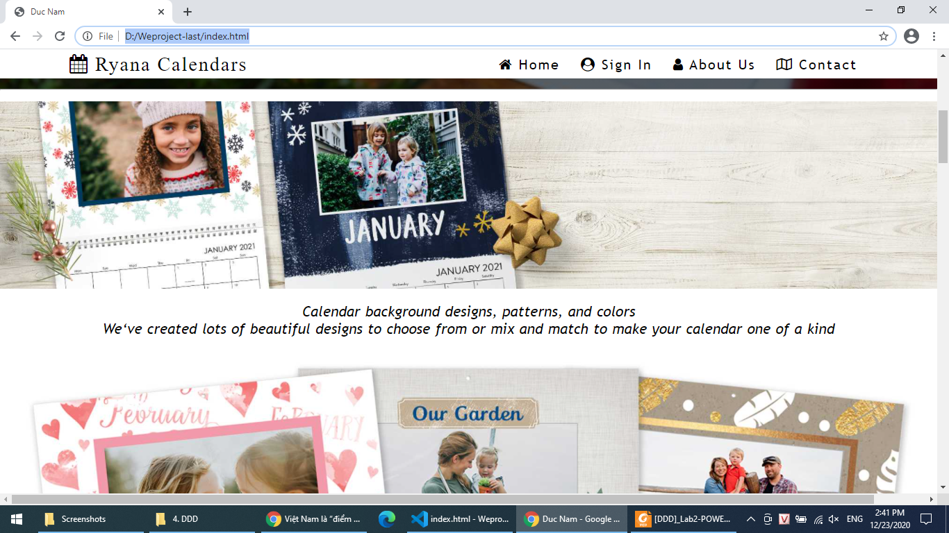

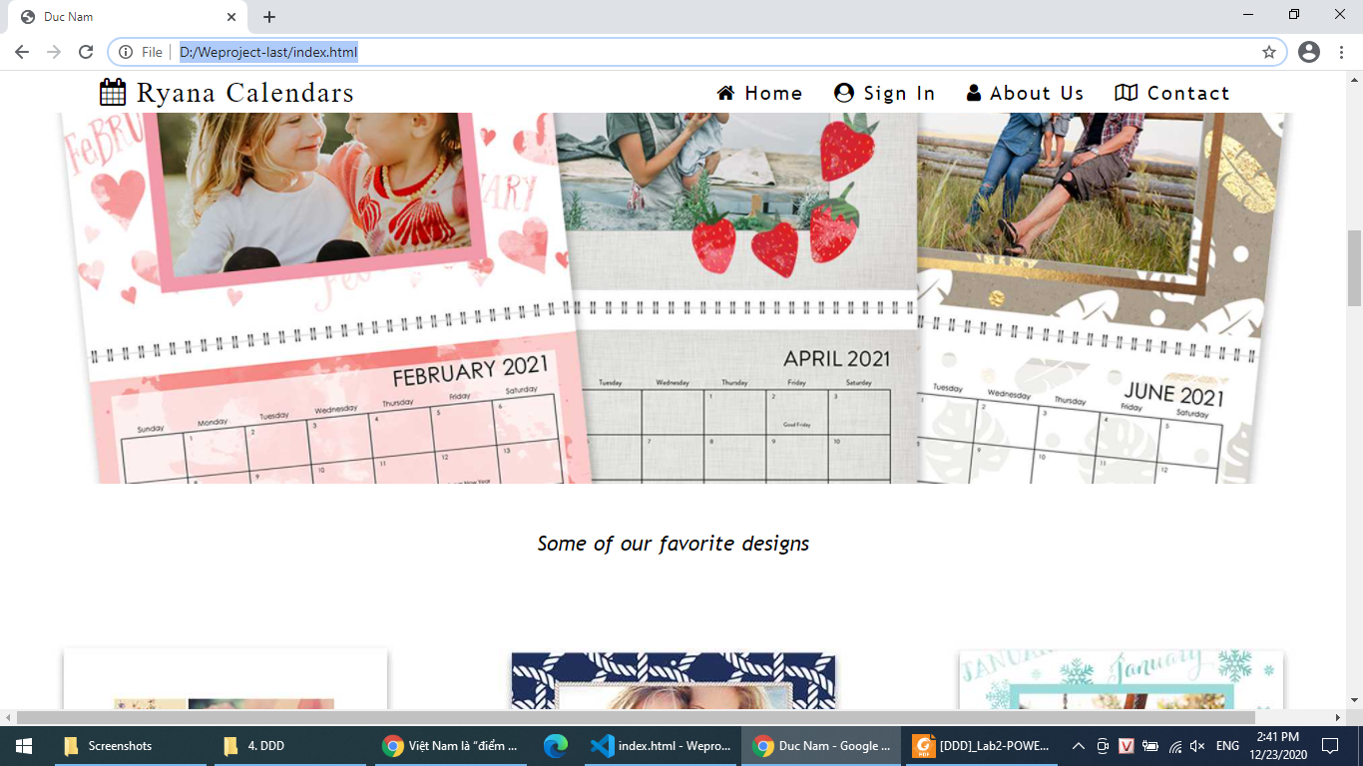

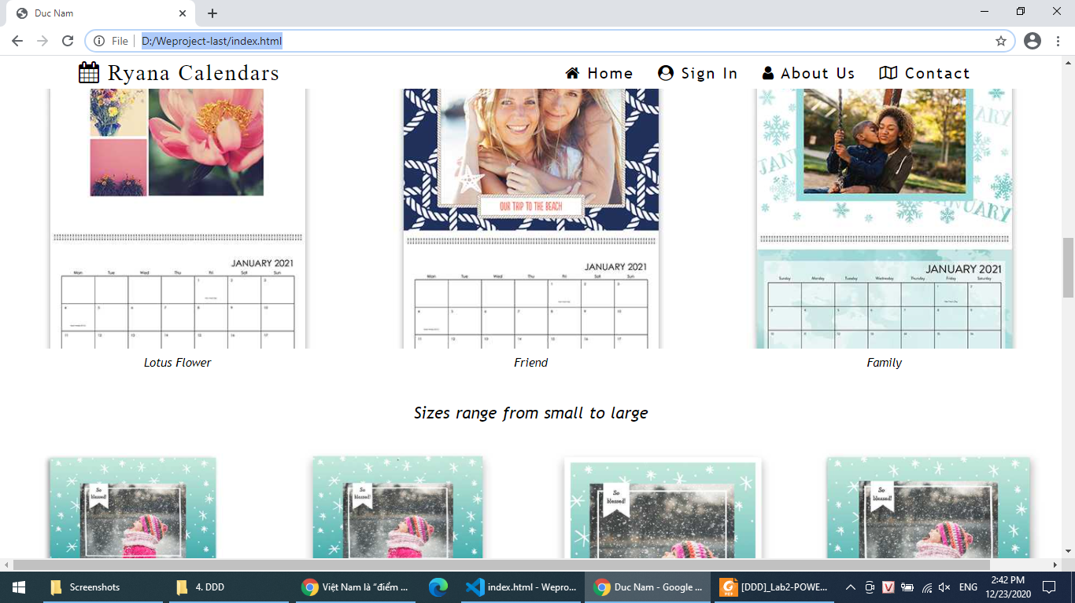

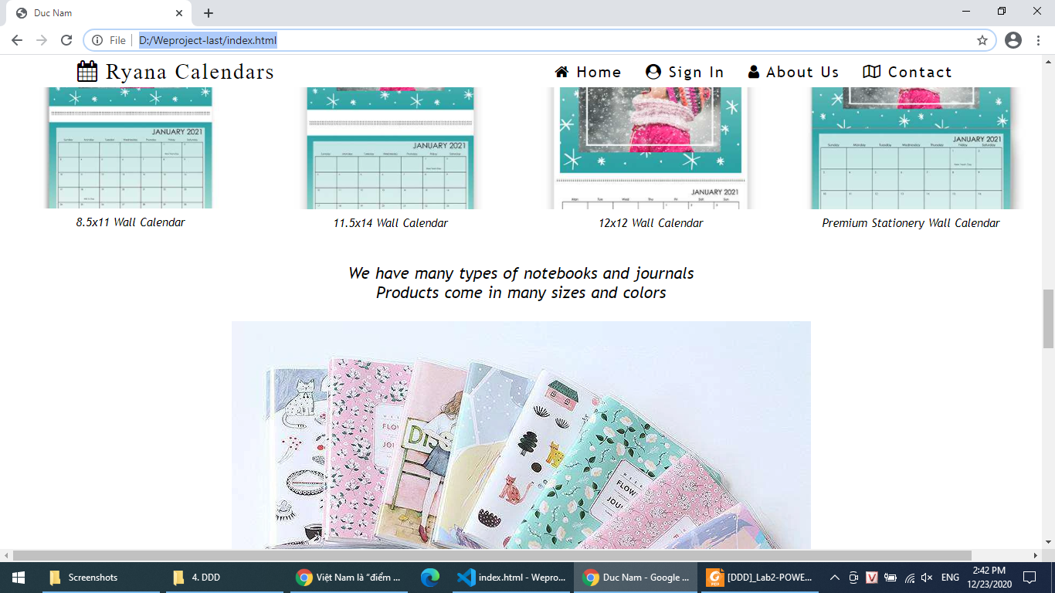

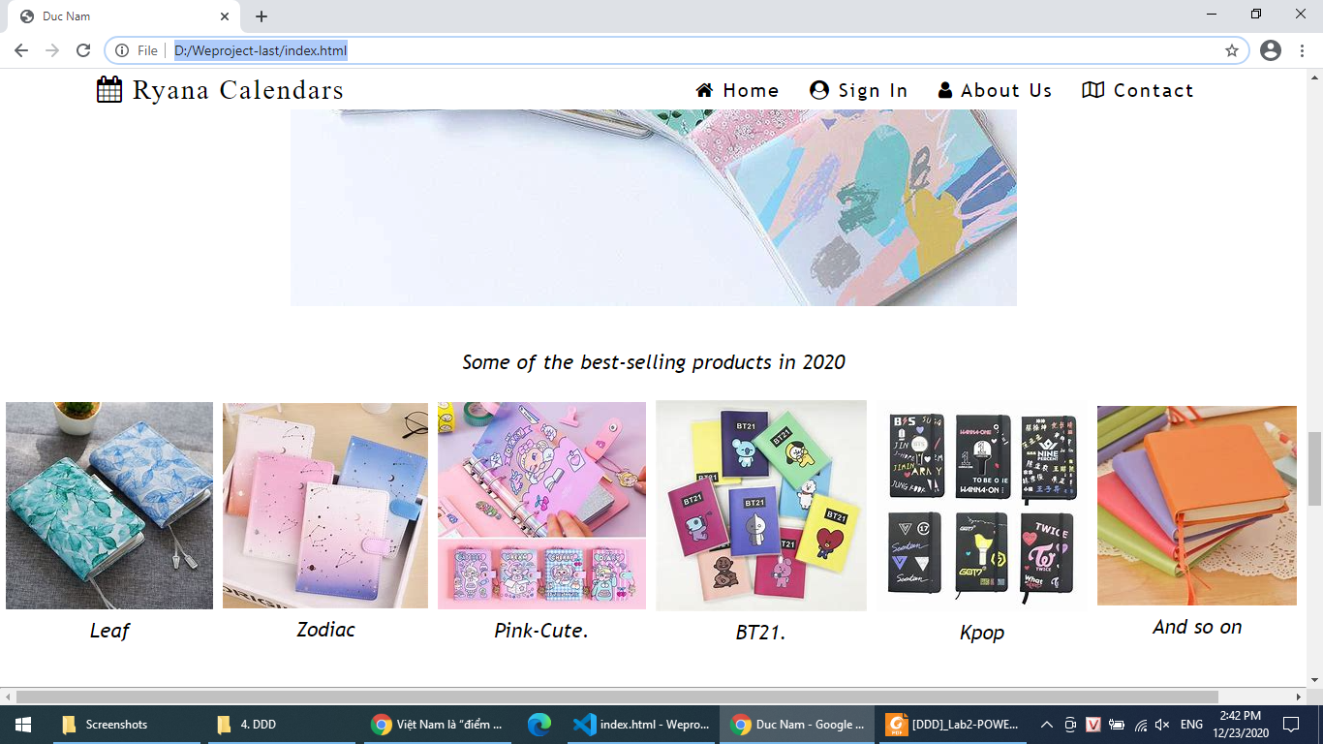

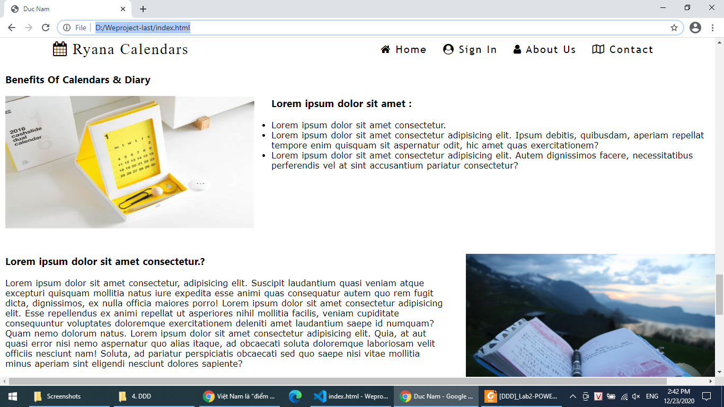

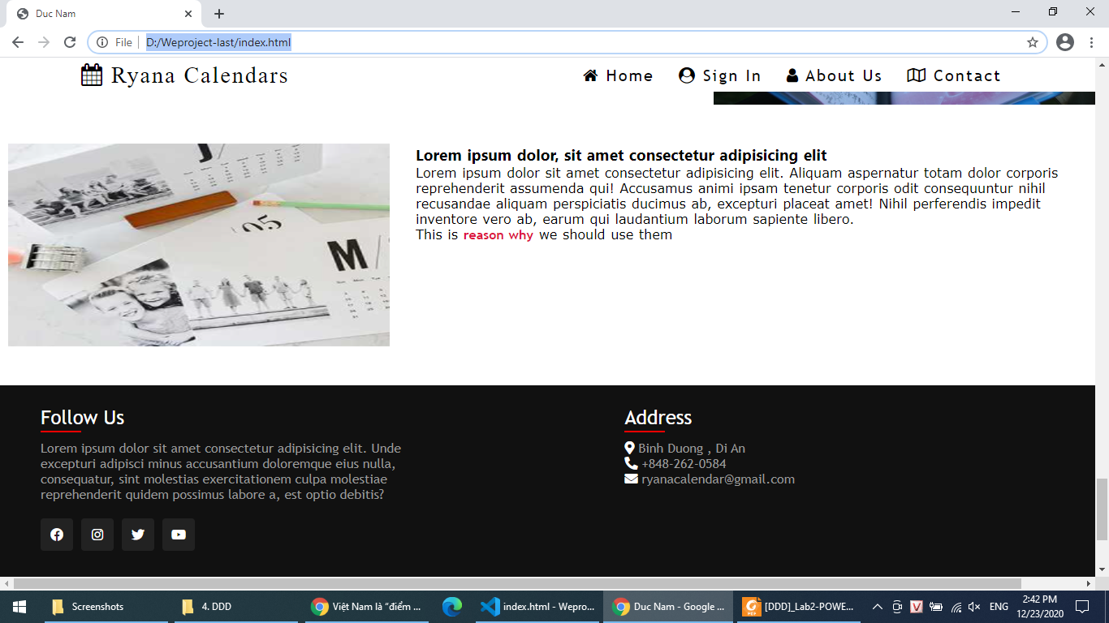

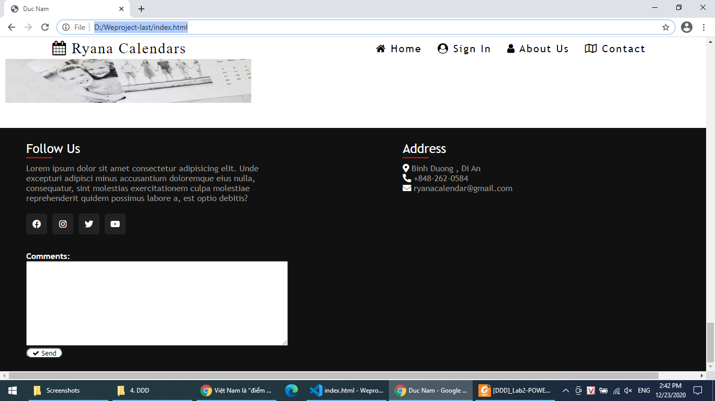

1. Sign In
2. Description

If customers want to buy and design diary and calendar they want they can sign in form or register form

1. Snapshot

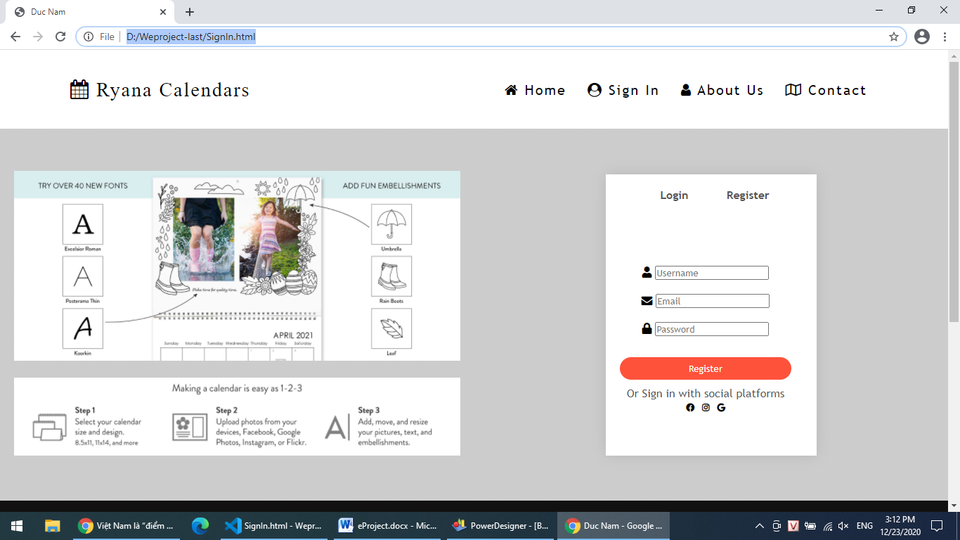

1. Diary
2. Description

You go to the shop online and buy some diaries.

1. Snapshot

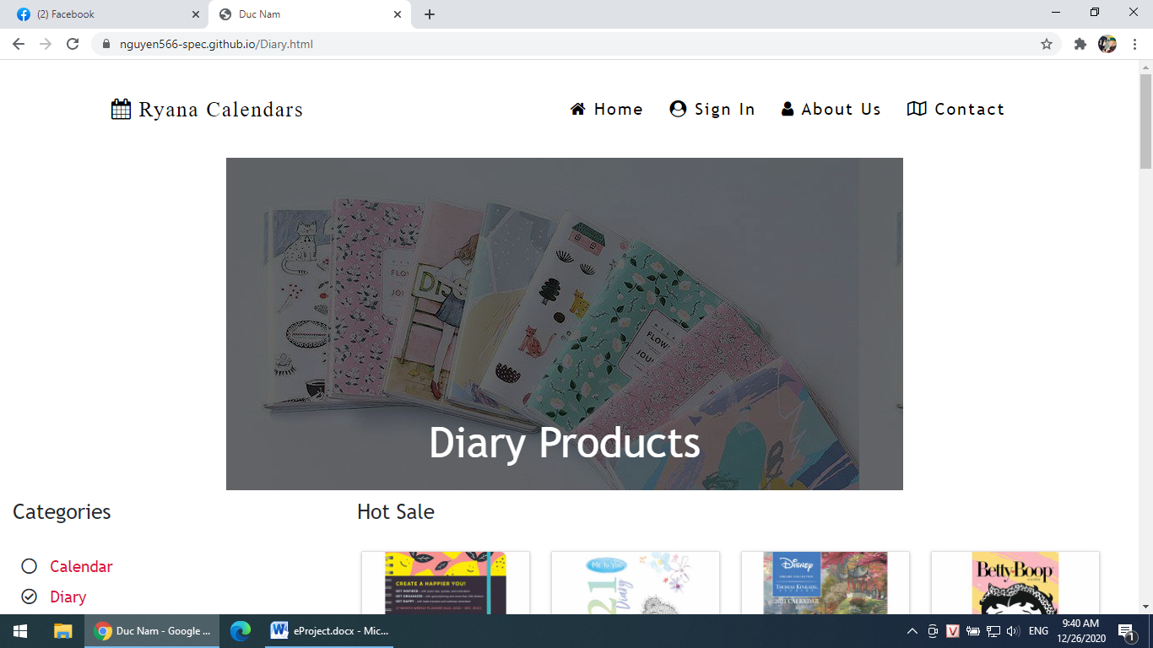

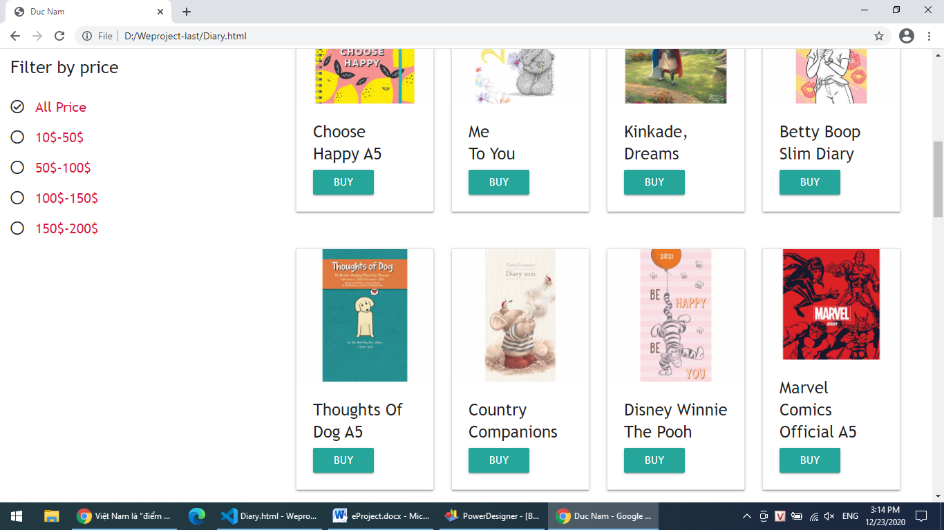

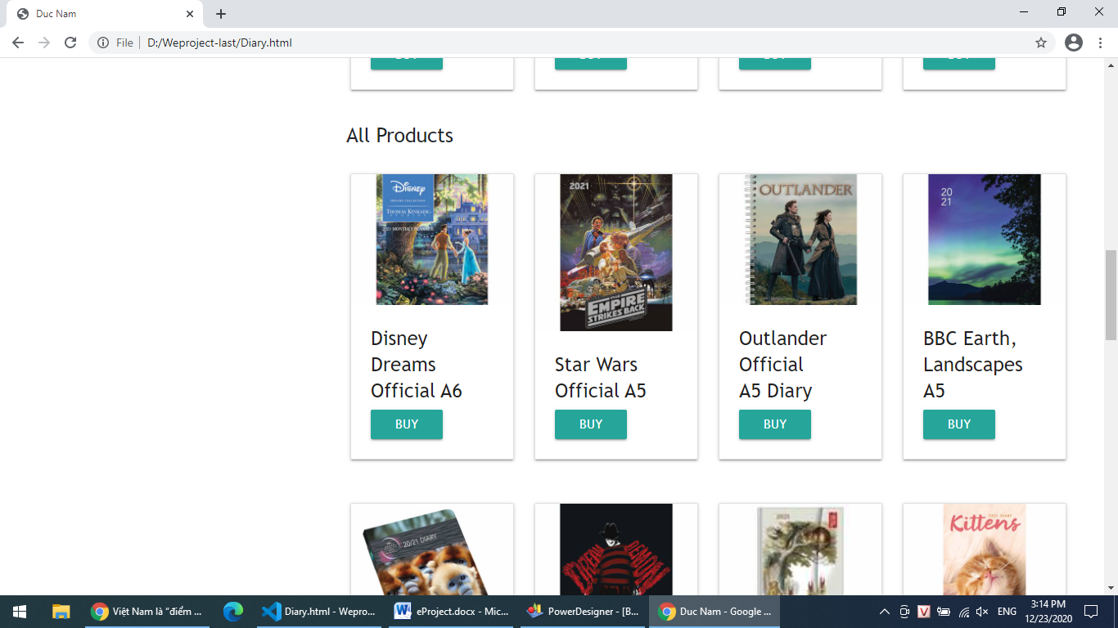

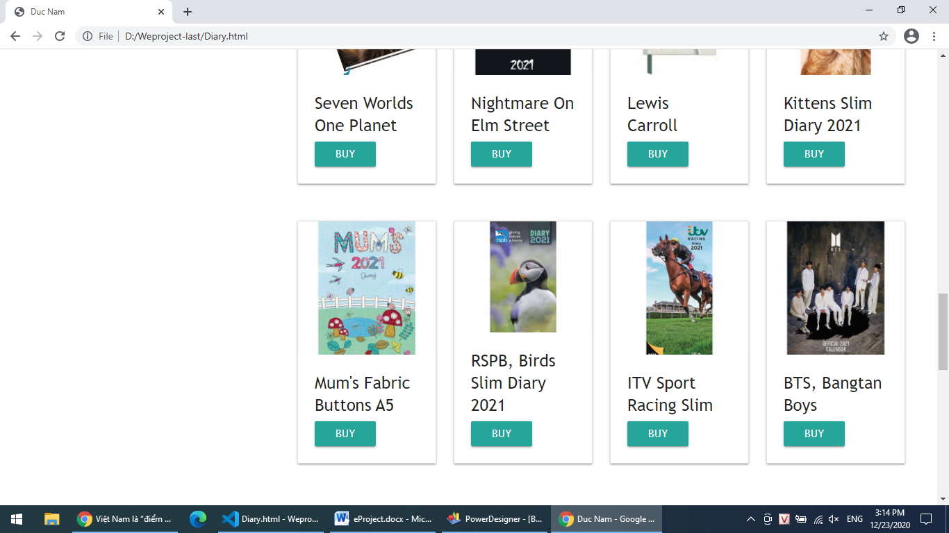

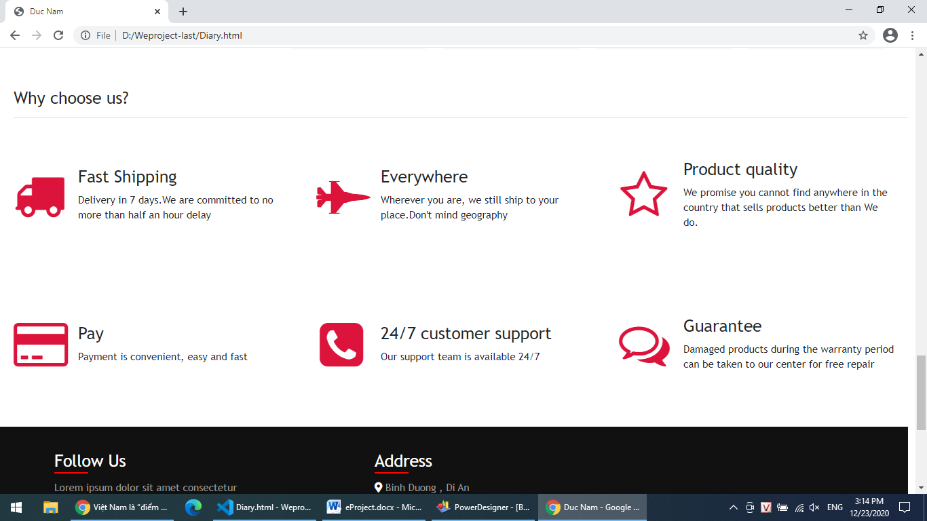

1. Calendar
2. Description

You go to the shop online and buy some calendars.

1. Snapshot

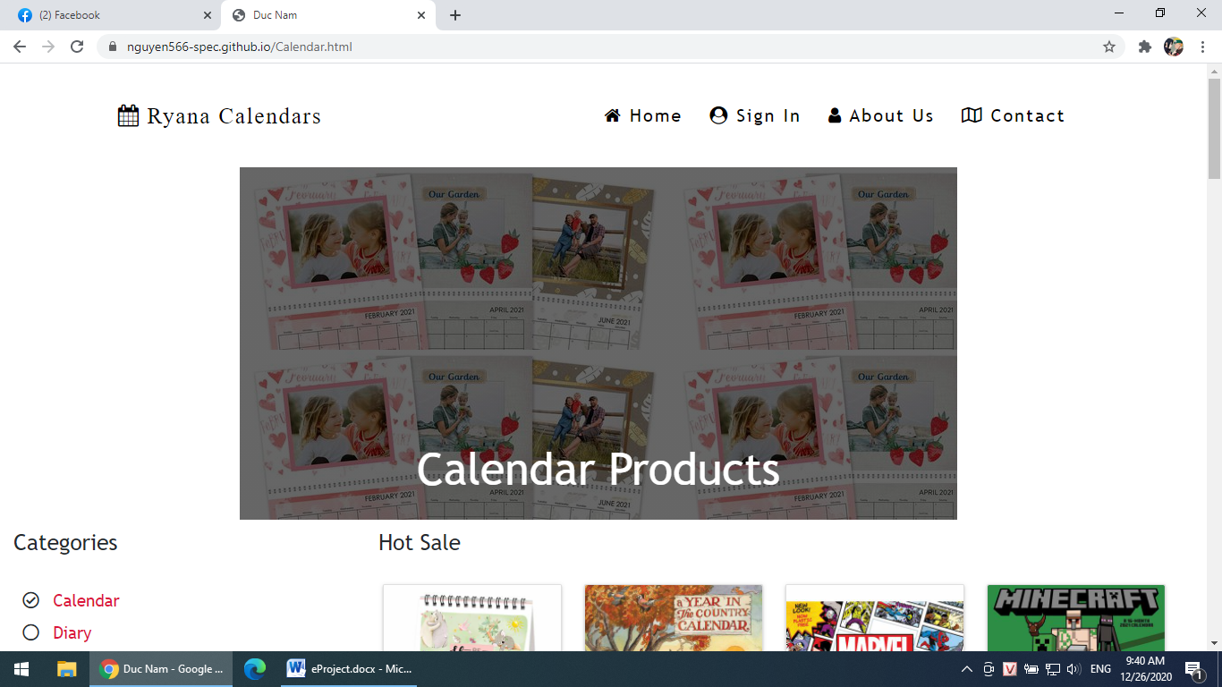

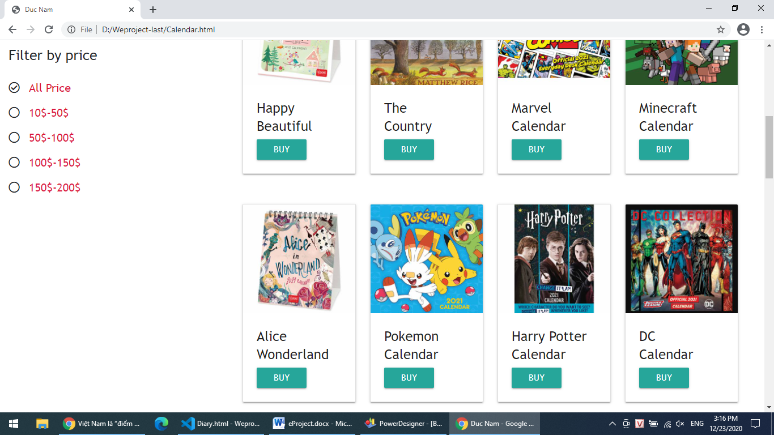

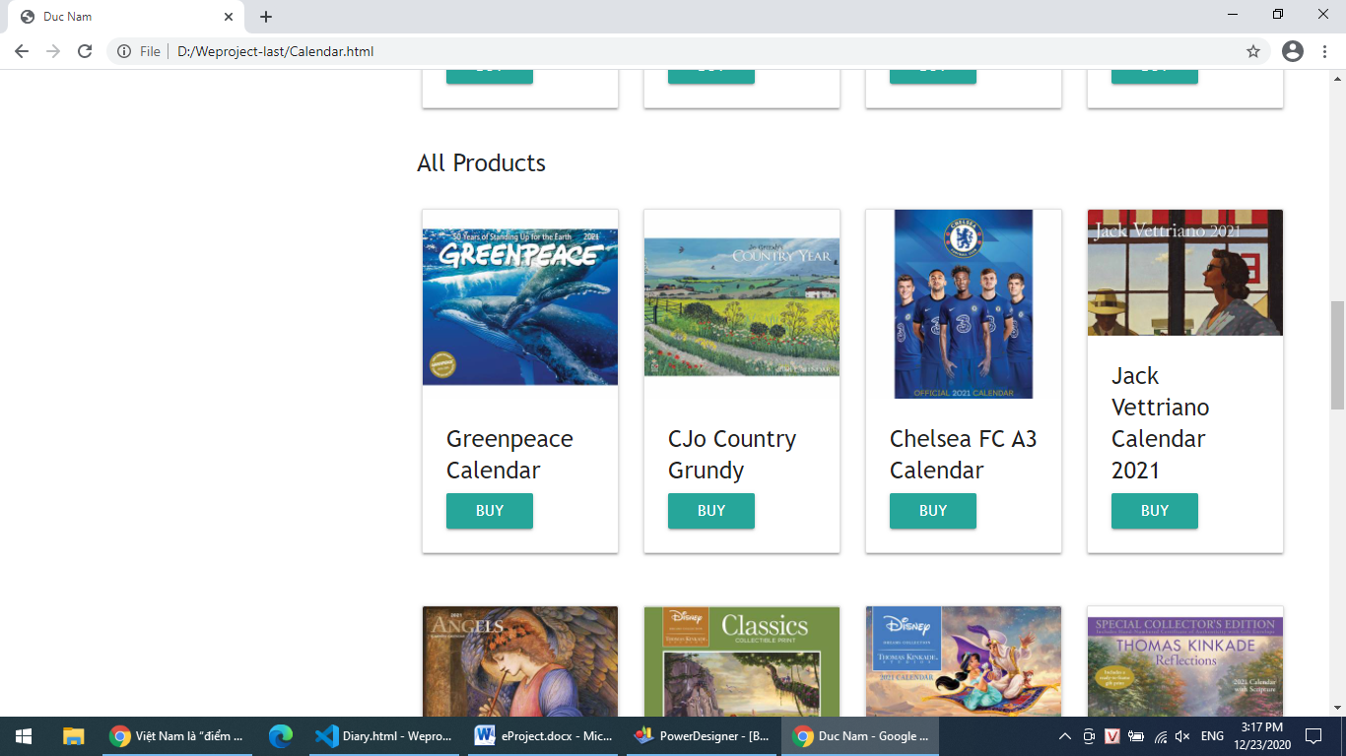

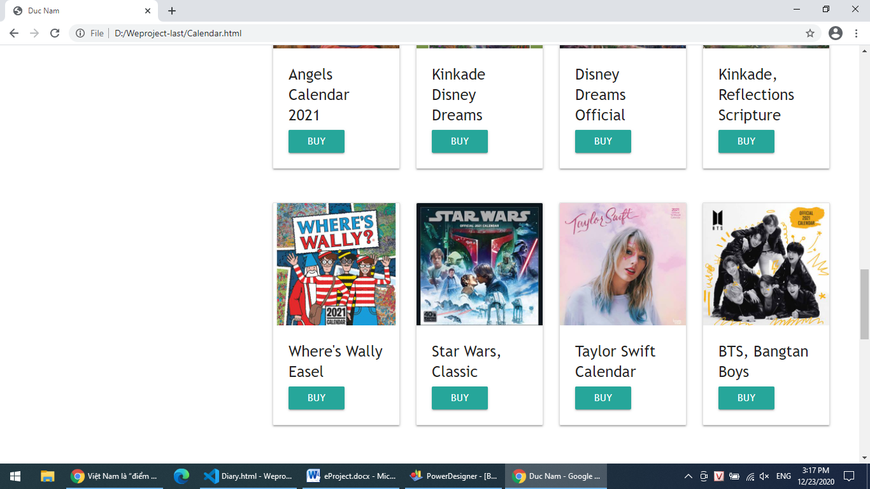

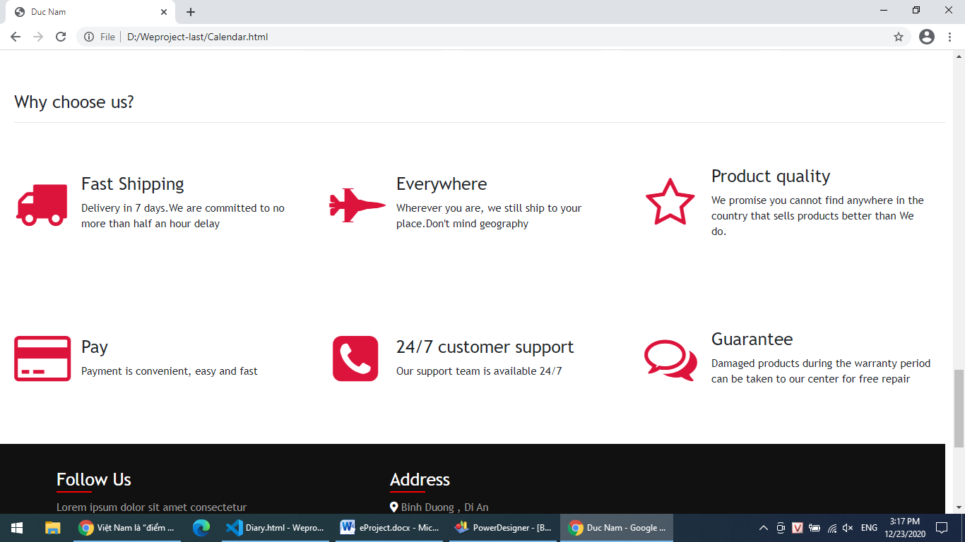

1. About Us
2. Description

We always support user fastest if we can , so user can contact with any member

develop team here. Everyone can contact us by Facebook, phone number and email.

1. Snapshot

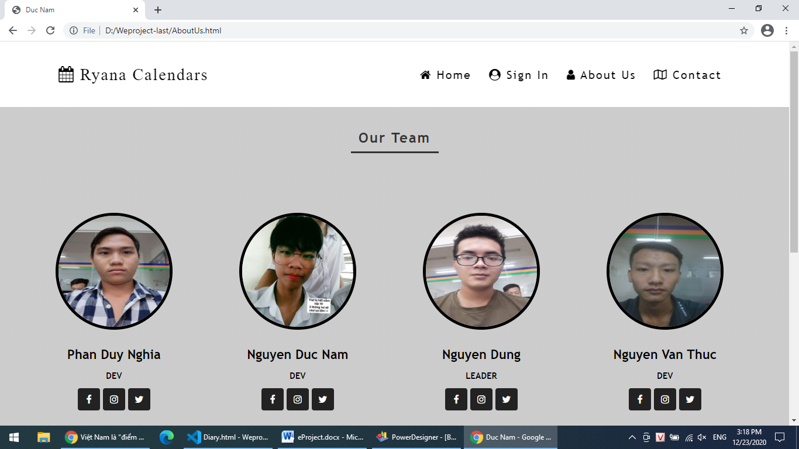

1. Contact
2. Description

Contact form help people connect with by normal way if they found wrong or error on

our website or they want to help us with new idea or anything else…

1. Snapshot

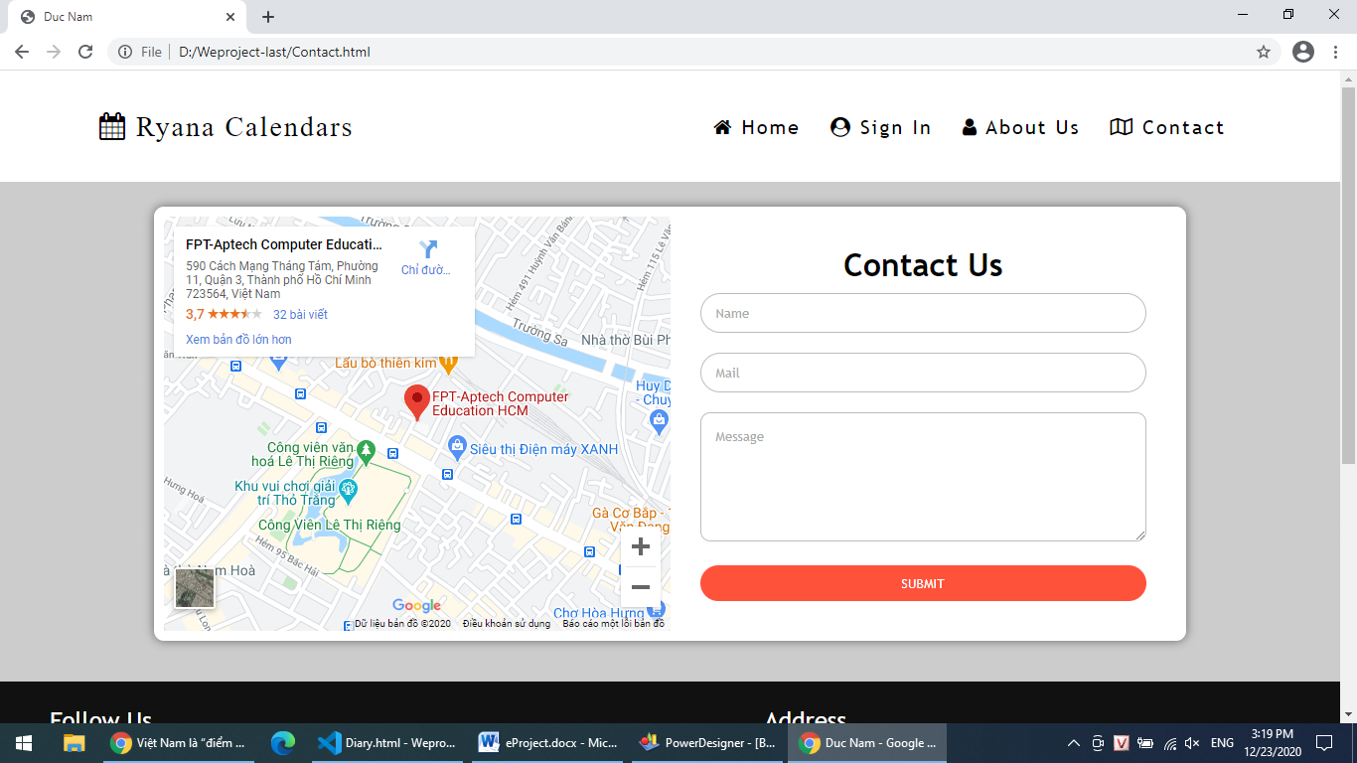

**JAVASCRIPT DESCRIPTION**

1. Slide Sign In form
2. Description

Change register form to login form and change login form to register form.

1. Screenshot

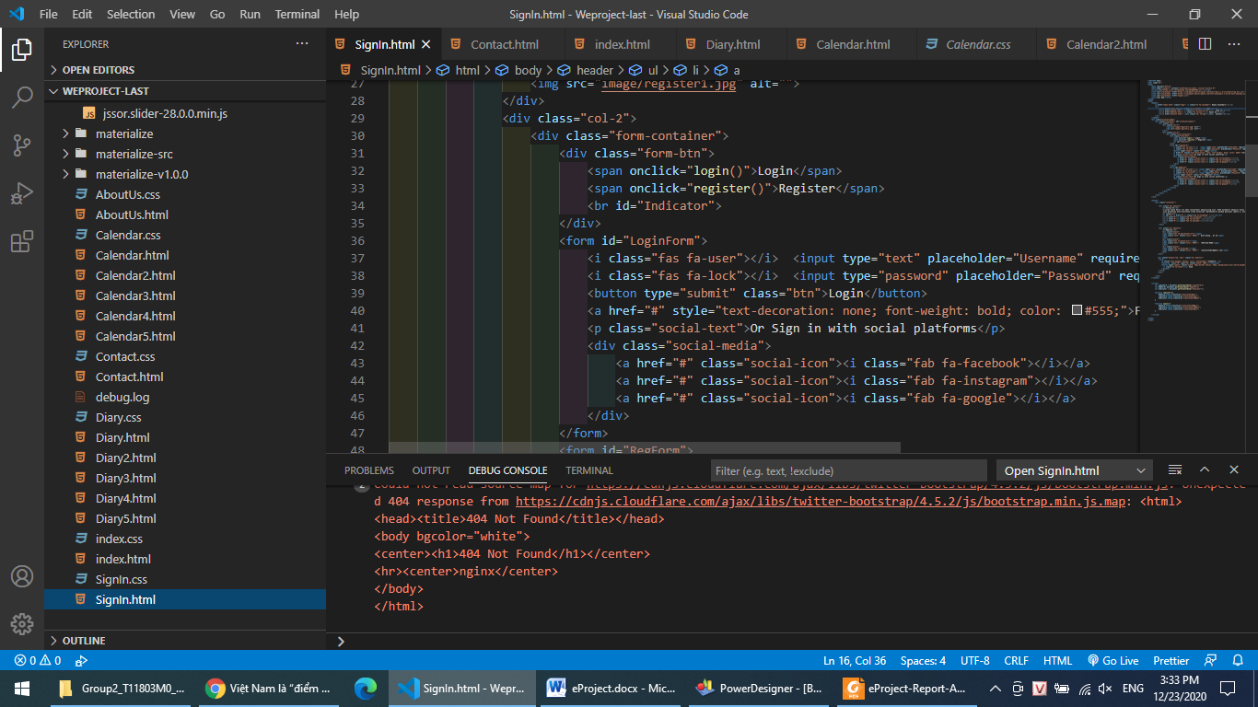

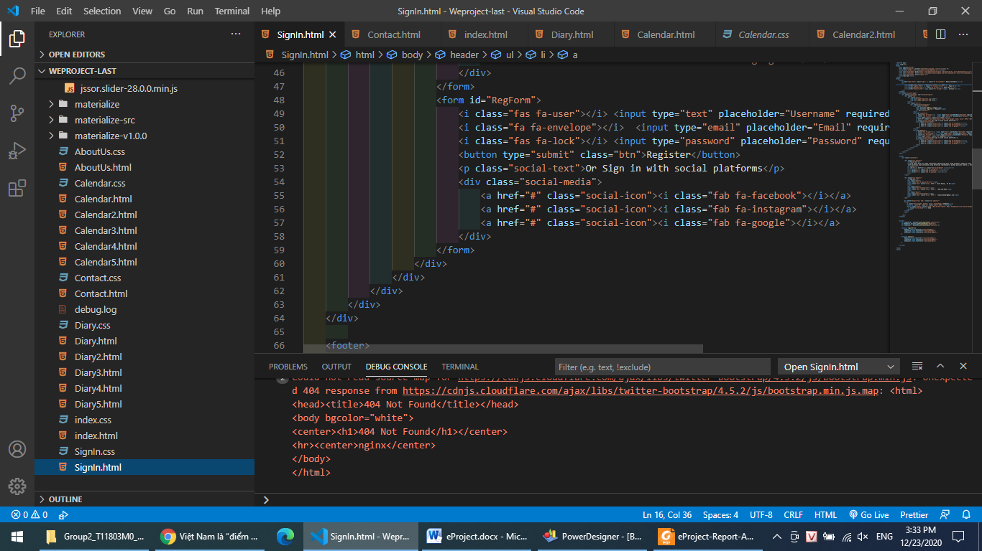

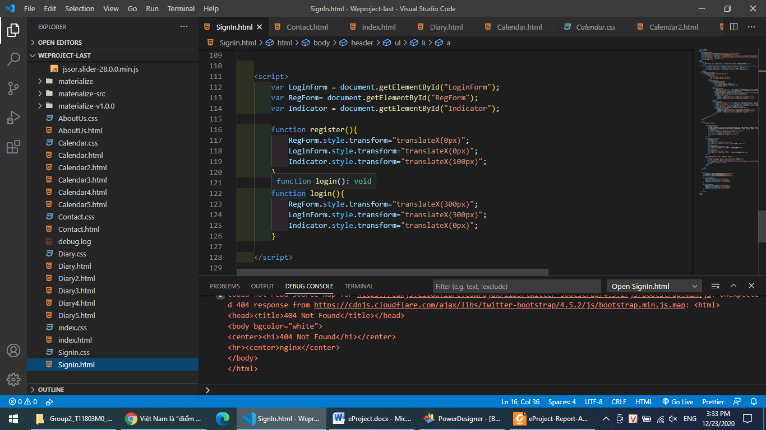

**TASK SHEET REVIEW 3**

|  |  |  |  |  |  |  |  |
| --- | --- | --- | --- | --- | --- | --- | --- |
| **Project Ref. No.:**  **eP/Advertisement** **Portal Management** **System/01** | | **Project Title:** | **Activity Plan** **Prepared** **By:** | **Date of Preparation of Activity Plan:** | | | |
| **Sr.No.** | **Task** | **Actual Start** **Date** | **Actual** **Days** | **Team** **Mate** **Names** | **Status** |
| 1 | Home | Ryana  Calendars | DUNG | 19/12/2020 | 1 | NAM | Completed |
| 2 | Sign In | 19/12/2020 | 1 | NAM | Completed |
| 3 | Diary | 19/12/2020 | 1 | DUNG | Completed |
| 4 | Calendar | 19/12/2020 | 1 | DUNG | Completed |
| 5 | About Us | 19/12/2020 | 1 | NAM | Completed |
| 6 | Contact | 19/12/2020 | 1 | NAM | Completed |

|  |  |
| --- | --- |
| **Date:** | |
| Signature of Instructor:  **Ms. Ngo Phuoc Nguyen** | Signature of Team Leader:  **Nguyen Duc Dung** |